Implementaion of DTMF Decoding

HENGYI SHEN
Department of Electrical & Computer Engineering
University of Maryland
College Park, US
forevercityu@gmail.com

Abstract—This report is focused on implementing DTMF decoding using FFT and filter methods respectively. Also matlab is used as a programing tool.
Keywords—DTMF;FFT; filter; matlab

Introduction
Dual-tone multi-frequency signaling (DTMF) is used for telecommunication signaling over analog telephone lines in the voice-frequency band between telephone handsets and other communications devices and the switching center.^{[1]} As a kind of multi-frequency systems, DTMF uses different combinations of frequencies to represent symbols like numbers and letters. To decode a DTMF signal, the key is to decide which two frequencies are used. In this project, both FFT and filters, especially band pass filters are used to obtain symbols represented.

Theory

DTMF
As said previously, DTMF uses different combinations of frequencies to represent symbols. A 4*4 matrix is used to show the match which can be seen in TABLE 1.

TABLE 1: DTMF KEYPAD FREQUENCIES MATCH
Frequency/Hz | 1209 | 1336 | 1477 | 1633
697 | 1 | 2 | 3 | A
770 | 4 | 5 | 6 | B
852 | 7 | 8 | 9 | C
941 | * | 0 | # | D

Letters ‘A’ to ‘D’ are mainly used in military instead of daily life, so they do not appear in phone keypad. Also, besides these 16 symbols, some lower frequency combinations are used to represent special tones like busy signal, dail tone and so on. Frequencies used to represent these special tones differ by areas and countries, however, all of them are not larger than 620Hz which will be used later in designing filter.
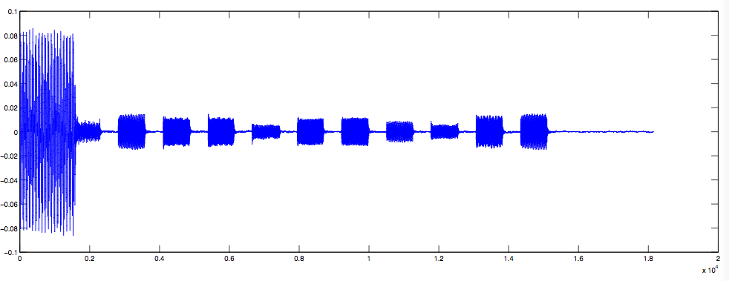
FIGURE1: input wav before filter

FFT
Fast Fourier Transform(FFT) is an algorithm to make computation of Discrete Fourier Transform(DFT) faster. By DFT, signals are converted from time domain to frequency domain, which makes it easier to do analysis. In this project, due to effect of noise, after DFT, there may be more than two frequencies having non-zero amplitude, but two of them should be relatively larger and they are actually the target frequencies.

Filter
In signal processing field, filters are mainly devided into 5 types: LPF(Low Pass Filter), HPF(High Pass Filter), BPF(Band Pass Filter) and BTF(Band Stop Filter). Another catalog methods is dependent on length of the impluse response: FIR(Finite Impluse Response) and IIR(Infinite Impulse Response).
Windows like Bartlett Window, Hanning Window, and Hamming Window can be used in FIR system. Butterworth and chebyshev window are used in IIR.
However, signals after filter usually do not have perfect sharp edge and this may cause some problem which will be discussed in discussion part.

Procedure
There are totally 3 steps to do the decoding.

Prefilter the input wav
Frequency between 697Hz and 1633Hz is valid for symbol representation. So a band pass filter with pass band 670Hz to 1700Hz is used here.In this case, frequency for special tone and some noise is filtered out, which can be seen in FIGURE 1 and FIGURE 2.
However, it can be seen that there is still a high amplitude stripe at the beginning of first symbol after filter. Such phenomenon is caused by the unrealistic of filters, that is the sharp edge problem in discussion part.

Get wav for each single symbol
- Get the envelop of input signal. By setting a proper normalize line((mean amplitude)/1.5), number of symbols and starting and finishing points of each symbol are determined. Thus a n*3 matrix is formed with no of symbol, starting point, finishing point being the columns respectively.
- For each of the n symbol wavs(named single wav), get the middle point and the sample to be processed is 3/5 of the total effective length of single wav. Reasons for these are disscussed in disscussion part.

Use FFT or filter to check frequencies

FFT method
After FFT, pure wav is converted into points in frequency domain. Target frequency has the highest amplitude. So by checking the peak point (highest amplitude), target frequencies are obtained. Then, symbol represented is clear.

Filter

Here chebyshev filter is used. Compared with Butterworth chebyshev has sharper edge and hence perform better in filtering.

DATA

FIGURE2: Single wav for ‘5’ before and after a filter
FIGURE3: input wav and the result wav after filters

discussion
- Sharp edge problem
Ideal filter has sharp edge which means no frequency out of band left. However, in that case, the filter is infinite in time domain which is impractical. Hence, we truncate the ideal impulse response with different kinds of windows. After truncation, implulse response is approximatly the same except at the edge. With out a sharp edge, frequencies out of the desired range will remain and affect processing of the signal.
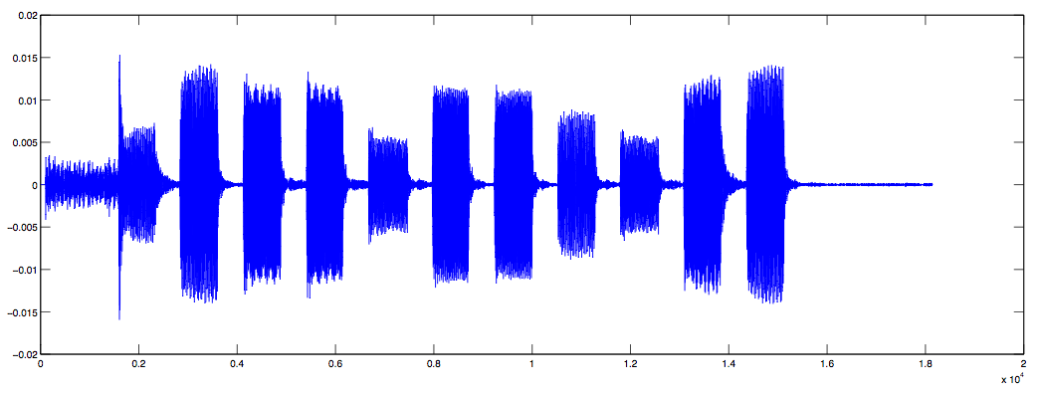
FIGURE2: input wav after filter

As shown in FIGURE2, the high amplitude stripe at the beginning of the first symbol is an example of effect of unsharp edge. Because of the high amplitude of dial tone frequency, the remainder of this frequency is still very large even after filtering. Thus the long stripe appears. As it is definitely above the normalized line, it will be processed together with the first single wav. This causes four frequencies appearing at the same time, which will mess up the decision making procedure. To solve this problem, we manually let the starting 100 points to be 0, which is not scientific but practical.
- Decision on sampling interval
After several steps before checking on frequencies, there may be some distortion on single wavs, especially on the edge. Moreover, frequencies are the same for every point in one interval, so we use 3/5 of every single wavs. The starting and ending point of a sample is obtained by the midpoint – length*3/10 and midpoint + length*3/10.
- Problem of gains

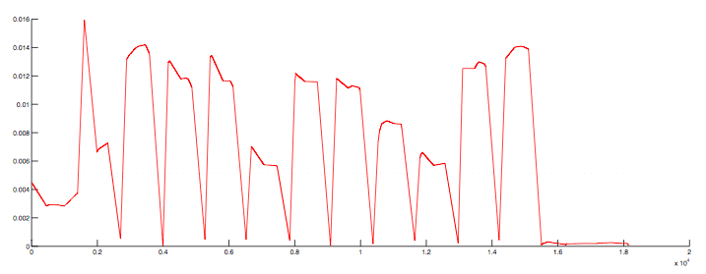
FIGURE3: Envelope of input signal

References

- http://en.wikipedia.org/wiki/Dual-tone_multi-frequency_signaling
- http://compgroups.net/comp.soft-sys.matlab/detect-frequency-of-dtmf-tone-wav-file/957018
- http://blog.sina.com.cn/s/blog_574d08530100qfrb.html

Appendix:

